template for KE5206 CI1, CA2 programming assignment submission

WANGZUXIU HONGWEIXIANG SURBHI TAYAL

NUS ISS

Abstract

In CA2 , we use SVM to do the classification problem in healthcare area by using heart diseases datasets. The dataset is a part of a database contains 14 features from Cleveland Clinic Foundation for heart disease. The dataset shows different levels of heart disease presence from 1 to 4 and 0 means no presence. Experiments with the Cleveland database have concentrated on simply attempting to distinguish presence (values 1,2,3,4) from absence(value 0).
After we do the data preprocessing and data engineering , we put all the selected features into SVM and tune the parameters and can get the accuracy at 68.3%(5 category values 0,1,2,3,4) and at 86.1%(2 category values 0 and others).
- Introduction

The aim of this project is to determine how likely a person to be suffering from a heart disease. With the help of many medical parameters of enough number of patients and the non-patients, we need to do feature engineering and train a suitable SVM model to figure out this problem.

Data Used : UCI Heart Disease Dataset.
The link of the dataset:
http://archive.ics.uci.edu/ml/datasets/heart+Disease
This dataset has 303 instances and contains 76 attributes, but all published experiments refer to using a subset of 14 of them.

This report presents the steps we took to build SVM model.
First, we discuss and explore the dataset we used to build our model. Then we do data preprocessing and build our baseline model. Lastly, we do feature engineering and select the features. Before we put all the feature into SVM,
we use validation curve and grid search to find the best parameters.
2. baseline approach

2.1. Data exploration

For the data preprocessing , we draw hist diagram for each attributes and see the relevance between the attributes and heart disease. Below shows the diagram for the age and sex.

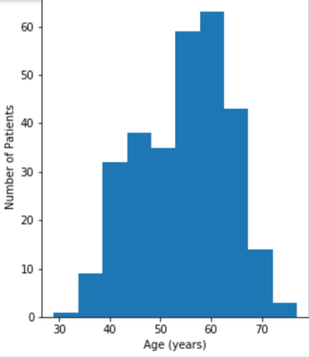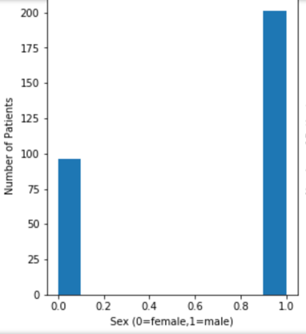

From the diagram, we can find age between 55 and 65 are more likely to have heart disease. And male are more likely to have heart disease than female. Other data exploration are shown in the file data exploration.ipynb.

2.2. Data preprocessing

Before we build our model, we need to do the data preprocessing. First we need to find all the category attributes and change them into one-hot encoding. After one-hot encoding , we have increased the attribute number from 14 to 26. Then we do the data normalization for the attributes of age, restbp, chol, thalach ,oldpeak. After normalization, these five attributes for the first five data from train dataset are shown as below.

Table1. attributes of first five data
 | age | restbp | chol | thalach | oldpeak
0 | 0.708333 | 0.481132 | 0.244292 | 0.603053 | 0.370968
1 | 0.791667 | 0.622642 | 0.365297 | 0.282443 | 0.241935
2 | 0.791667 | 0.245283 | 0.235160 | 0.442748 | 0.419355
3 | 0.166667 | 0.339623 | 0.283105 | 0.885496 | 0.564516
4 | 0.250000 | 0.339623 | 0.178082 | 0.770992 | 0.225806

2.3 Model train and selection

After we get the features , we put them into the SVM and train the model. We split train and test dataset randomly by using sklearn train_test_split. SVM is a supervised learning models with associated learning algorithms that analyze data used for classification and regression analysis. For our baseline approach , we put our features into the sklearn svc model with the default parameters. We use the train dataset to train the model and use the test dataset to validate our model.

3. proposed approach

3.1. Use SelectKBest to select features

We use SelectKBest from sklearn to do the univariate feature selection. This method based on univariate statistical tests to find the best parameters. It is mostly used in the preprocessing stage before building model. After serial experiments, we choose k = 10 to find the best 10 features.

3.2. Fine tuning SVM model parameters

It takes two steps to do the parameters fine tuning. First we use the validation curve to find the best range of c and gamma. To avoid over-fitting, we use k fold (cv=5) to get the best parameters.

First we give a range of [1.e-02,1.e+05] on the parameter C. We use the validation curve to find the best parameter gamma. The validation curve with SVM and score are shown as below.
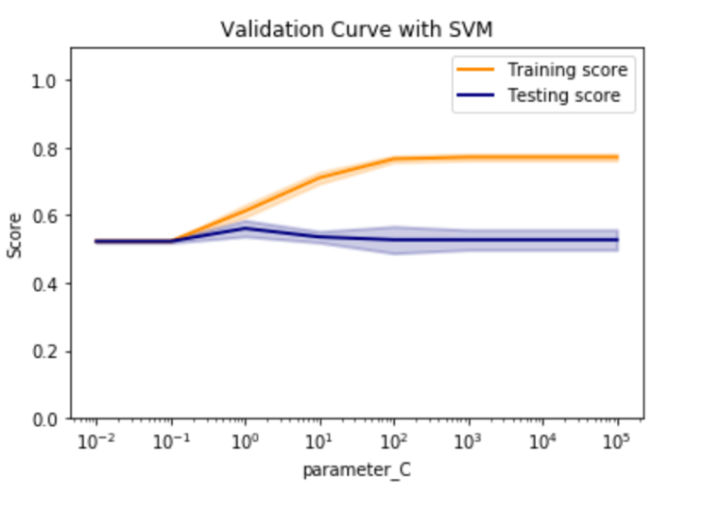
From this graph, we can find before 1.e+02 , the training score is rising and after 1.e+02, the training scores does not change and close to 0.8. The testing score peak at 0.58 when C equals to 1. The C parameter tells the SVM optimization how much you want to avoid misclassifying each training example. For large values of C, the optimization will choose a smaller-margin hyperplane if that hyperplane does a better job of getting all the training points classified correctly. Conversely, a very small value of C will cause the optimizer to look for a larger-margin separating hyperplane, even if that hyperplane misclassifies more points.

Then we find the best parameters of gamma. We give a range of [1.e-04,1.e+01] on the parameter gamma . We use the validation curve to find the best parameter gamma. The validation curve with SVM and score are shown as below.
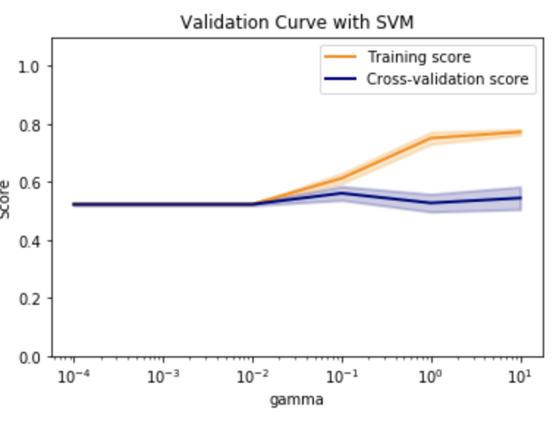
From this graph, we can find the best range of gamma is between 1.e-02 to 1.e+00.

Then based on the range of best parameters , we do the grid search to find the best parameters. The best parameters is 10 for C and 0.05 for gamma. Then we build our SVM model based on our best parameters.

4. experimental results

4.1. For baseline approach

We get the accuracy of 61.67% for five category(values 0,1,2,3,4) and 84.44% for two category(disease and no disease).

4.2. For proposed approach

We get the accuracy of 68.33% for five category(values 0,1,2,3,4) and 88.33% for two category(disease and no disease).

4.3 Result analysis

Confusion matrix
 | Pre_0 | Pre_1 | Pre_2 | Pre_3 | Pre_4
Real_0 | 36 | 0 | 0 | 0 | 0
Real_1 | 4 | 2 | 2 | 0 | 1
Real_2 | 0 | 2 | 1 | 2 | 0
Real_3 | 1 | 0 | 3 | 2 | 1
Real_4 | 1 | 1 | 0 | 1 | 0

From the confusion matrix ,we can find that our model works well on no disease (value 0) prediction ,while works bad on heard disease (value 4). It is because we do not have enough training data for value 4. The unbalance training sample causes the low prediction for value 4.

5. conclusions

We use SVM to do the classification problem based on heart disease datasets. The goal of our analysis was to build a classifier that accurately determines if a patient has heart disease and the level of the heart disease. Our SVM model has an accuracy of 68.33% to distinguish different level of heart disease and 88.3% to distinguish if a person have heart disease.

However several shortcomings of our approach should be noted. The size of the dataset, 303 observations, is small relative to the size of the general population. We need more datasets to train our model and get a better result.

6.Usage

Tools: Ipython notebook.
Data file: heart_disease_all.csv
Data Exploration: data exploration,ipynb
Baseline approach:heart disease_svm_baseline.ipynb
Proposed approach: heart disease_svm_proposed.ipynb

References

[1] P. H. Chen, C. J. Lin, and B. Schölkopf, “A tutorial on ν-support vector machines”, Appl. Stoch. Models. Bus. Ind. 2005, 21, 111-136.

[2]Divyansh Khanna, Rohan Sahu, Veeky Baths, Bharat Deshpande, “Comparative Study of Classification Techniques (SVM, Logistic Regression and Neural Networks) to Predict the Prevalence of Heart Disease”, DOI: 10.7763/IJMLC.2015.V5.544

[3]Majid Ghonji Feshki, Omid Sojoodi Shijani, “Improving the heart disease diagnosis by evolutionary algorithm of PSO and Feed Forward Neural Network”, Conference: Conference: 2016 Artificial Intelligence and Robotics (IRANOPEN)

[4] J. Nahar, “Computational intelligence for heart disease diagnosis: A medical knowledge driven approach,” Expert Systems with Applications, pp. 96-104, 2013.

[5] N. Cheung, “Machine learning techniques for medical analysis,” B.Sc. Thesis, School of Information Technology and Electrical Engineering, University of Queenland, 2001.

